**Electronic System for Navigation of Visually Impaired People**

*Jyoti Madake1, Bhumika Bijane2, Geetai Charde3, Abhijit Chine4, Shripad Bhatlawande5, Swati Shilaskar6

1Vishwakarma Institute of Technology, Pune, India

1*jyoti.madake@vit.edu, 2bhumika.bijane19@vit.edu, 3geetai.charde20@vit.edu, 4abhijit.chine20@vit.edu, 5shripad.bhatlawande@vit.edu, 6Swati.shilaskar@vit.edu,

*Abstract*— People who are blind or visually challenged require frequent support when moving from one location to another. A smart device can help assist a blind person in the best possible way. In this research paper, the proposed system gives a path to the user to reach one of the 10 destinations from one of the source positions. The system is designed to provide guided instructions on 100 chosen paths. The interface for path selection is user-friendly considering the limitation of the blind person. System mapped an appropriate route for their selections. This system has voice help and is user-interactive.

K*eywords — Path Planning, Visually Impaired, Voice Assistance System, and User Friendly*

# **INTRODUCTION**

The most crucial thing is vision, which allows you to view the world around you. Several components within your eye and brain work together to give you vision. Vision loss can occur for a variety of reasons as stated by [1] [2]. These could be caused by eye damage, the brain's inability to accept and interpret visual cues supplied by the eyes, and so on. A functional limitation of the eye or eyes, or the vision system, is referred to as visual impairment. As a result [1] the person loses visual acuity and is unable to perceive objects as clearly as a healthy person. Loss of the visual field refers to an individual's inability to see as far as the ordinary person without moving his or her eyes or rotating his or her head. There were an estimated 253 million people with vision impairment globally, according to Worldwide Statistics for Blindness and Visual Impairment [3] [4]. 36 million were blind, with another 217 million suffering from moderate to severe visual impairment (MSVI). People with range visual impairment account for 3.44% of the population, with 0.49% being blind and 2.95% having MSVI. One further 1.1 billion people are thought to be affected by functional presbyopia. Most eye diseases become more common as people get older; as a result, the prevalence of blindness and MSVI is substantially higher in older age groups. 80 % of the 253 million visually impaired people on the planet are above the age of 50. Women account for 55% (139 million) of the world's 253 million visually impaired people, while males account for 45%. Blind folks have their own way of doing things and lead normal lives. They do, however, confront difficulties as a result of inaccessible infrastructure and social issues. Navigating around locations is the most difficult task for a blind person, especially one who has lost all eyesight. The majority of people with visual impairments prefer to use a long walking cane as an aid in their daily mobility activities. The most basic, adaptable, and low-maintenance assistive device is a white cane [5] [6].

A guide dog is useful to detect and avoid barriers in the course of travel, and also extreme circumstances [7]. The Medico Stick allows people who are blind to confidently walk down the road [8], both the white cane and the guide dog, give a brief description and are unable to identify overhead objects. Since then, a descriptive and analytical study has been performed. Many mobility aids have been created in recent decades to address such problems, namely obstacle avoidance [9] understanding maps [10] [11], and navigating in unfamiliar places [12] [13]. There are numerous existing systems that are based on sonar [14, 15, 16]. There are several types of navigation systems, including Ultrasonic sensor-based navigation [17], GPS-based system [18], Laser-based navigation i.e. Laser cane [19], and Teletact [20]. A GPS-based system was implemented for navigation. With the help of a secure and effective navigation device namely GPS [21] this system covers unusual routes as well as unexpected destinations. Another approach for the goal of guiding visually challenged people, GPS and voice recognition, as well as obstacle avoidance [22]. An Android GPS-Based Navigation Application for Blind, the application is proposed for traveling from one place to another [23]. RFID and GPS Integrated Navigation System, the system uses RFID and GPS based localization while operating indoor and outdoor respectively [24]. GPS and GSM methods are used to create a navigation system for blind persons. A walking stick with a microcontroller, infrared sensors, a GPS receiver, label surface detection, a buzzer, and a vibrating motor have been constructed to assist a blind person in detecting obstacles and navigating to their destination [25]. In this case, navigation refers to a process that involves moving from one location to another. Visually impaired people require the assistance of others in order to travel and are dependent on others to transport them from one location to another. This work proposed one such system that builds a path from current places to their destinations using input from a keypad with pre-assigned keys. Considering a person's decision of where they want to travel using pre-assigned keys from a keypad and system mapped an appropriate route for their selections. This system has voice help and is user-interactive. This is a very safe and reliable navigation system that allows many blind people to travel without worrying about their position or course guidance while on the go. So that blind people can travel and move around independently even in uncomfortable situations.

# **Methodology**

This paper presents an electronic system for the navigation of visually impaired people. Fig.1. Shows a block diagram. It consists of a numerical keypad, processor-based system, internet dongle, and earphones. It accepts the source and destination of the known locations such as school, tea stall, clinic, market, bus stop, temple etc. from user and complies a path. It provides details of the identified path to the user through earphones and generates a map for functional verification.

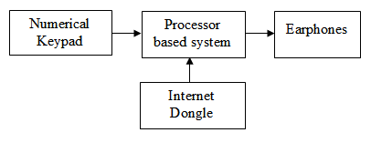

**Fig.1.** System Schematic

Two datasets are created for the system. The first dataset is of source and destination and the second is for the waypoint. The first dataset contains 4 columns and 10 rows in the excel file. Columns include Loc_id (key number) to which key specific destination is assigned. The second column is about the locations. The third and fourth columns contain the respective latitude and longitude of a location is mentioned in Table I. Location dataset.

**Table I.** Location dataset

|  |  |  |  |
| --- | --- | --- | --- |
| **Loc_id** | **Location** | **Latitude** | **Longitude** |
| 0 | VIT | 18.46362 | 73.86819 |
| 1 | Dolphin chowk | 18.46135 | 73.86631 |
| 2 | Sukhsagar nagar | 18.45653 | 73.87011 |
| 3 | Lake town | 18.45743 | 73.86403 |
| 4 | Manapa Bus Station | 18.52319 | 73.85383 |
| 5 | Chintamani nagar | 18.46631 | 73.86618 |
| 6 | Mahesh society | 18.46905 | 73.86505 |
| 7 | Bibwewadi police station | 18.46733 | 73.86414 |
| 8 | K K market | 18.46987 | 73.85843 |
| 9 | Swargate bus stand | 18.49715 | 73.85806 |

The second dataset is of waypoints between the source and the destination. It contains 6 columns. First column is waypt_start_id that indicates key number of source location. Second column is waypt_stop_id that indicates key number of destination location. Third column is waypt_seq indicating number of waypoints between source and destination in sequential manner. Fourth and fifth columns are waypt_lat and waypt_long contain the latitude and longitude of waypoints respectively. And last column is waypt_nm contains the name of the waypoints between the source and destinations.

System asks the user to enter the key of the source location among the 10 locations from table 1 and then to enter the key for destination location as mentioned in Fig.2. the data is used to calculate waypoints.

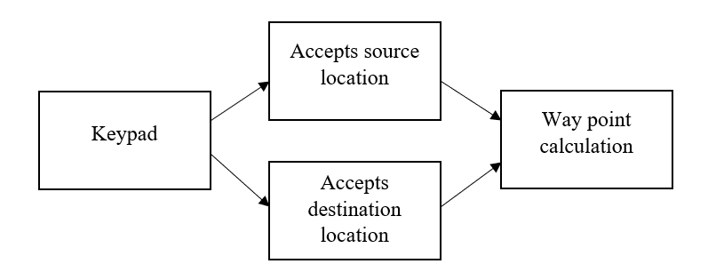

**Fig.2.** Initial phase (accepting input)

Fig.3. shows the calculation of waypoints between source and destination. If the selected source ID is less than the destination ID then the loop is executed in the increasing order of the waypoint sequence. Otherwise, loop is executed in the decreasing order of the waypoint sequence.

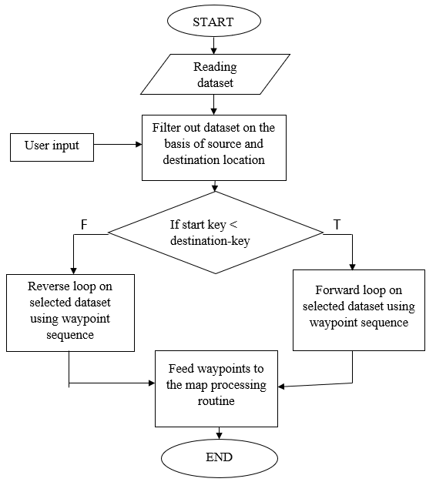

**Fig.3.** Calculation of waypoints

Algorithm 1 shows the calculation of the waypoints. The calculated waypoint is then given to the next part of the model i.e. path planning.

**Algorithm 1 Calculating waypoints**

**Input** Waypoints

**Output** Path

1. Reading waypoints dataset and taking source and destination keys from the user.
2. Filter out dataset on the basis of source and destination key
3. **If** **start_id < destination_id**:

Execute forward loop on dataset using waypoints sequence

**else**:

Execute reverse loop on dataset using waypoints sequence.

1. Pass the calculated dataset list to the map processing function of algorithm 2.
2. Display map and plot all the locations / waypoints on a map using algorithm 2.
3. **End**

Fig4. shows integration of computed path with Google Map and Audio output. As the system displays the path on the google map at the same time it will also give the audio output of the track between entered source location and the destination location to inform the blind person.

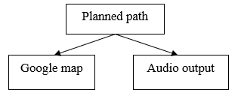

**Fig.4.** Integration of path with Google Map and audio output

If the input is less than or equal to 10, then the second condition of user conformations is executed. Otherwise, system will utter invalid input as shown in Fig.5. The required output is displayed as well as given as a voice message.

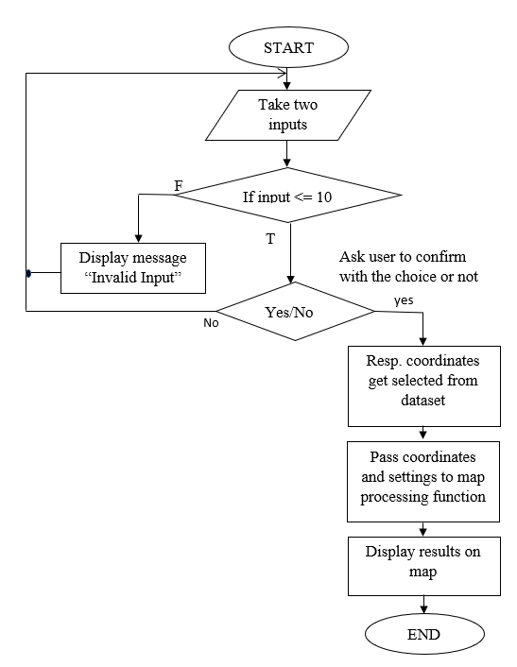

**Fig.5.** Flow diagram for path planning

Algorithm 2 shows that the waypoints are given and then it completes the calculations of path planning and as a result of it output is shown on the map and a voice message.

**Algorithm 2 Path planning**

**Input** Source and destination

**Output** Map showing shortest path from source to destination

1. Importing required Libraries and Google map API key.
2. Define functions for voice message and text to speech conversion
3. Reading predefined location dataset.
4. Taking source and destination location ids from the user and give a voice message
5. Validating users input:

**If** **Loc_id < = 10:**

Proceed further

**Else**:

Back to ask user’s input (step 4).

1. Confirm the user’s input (Yes / No):

**If input = = Yes:**

Proceed further

**Else**:

Back to ask user’s input (step 4).

1. Select location details (location name, longitude, latitude) from the dataset on the basis of user’s input.
2. Pass coordinates waypoints list (from algorithm 1) and configurations to the map processing function.
3. Give voice message for the planned path
4. **End**

The system is only designed to provide the path between sources and destination mentioned in the dataset. If the user presses any invalid key then the system will utter the message “Invalid key” and again ask the user to press valid key for source and destination. The Google Directions API is used to design the path. This API plots the result on the map. Google Map is used for the functional verification of routes and waypoints. The blind person will get to know the correct path before starting his journey so that the user can start his plan. The proposed can be either deployed on low cost microcontroller based device or can be ported on android based mobile phone. The cost associated with its development is low and the navigation assistance provided by this device is efficient.

# **Result**

The entire path planning trial was run using a blind person. The user has entered ‘1’ for the source as Dolphin Chowk and ‘0’ for the destination as V I T and requested for path planning. There were total 3 waypoints in between them which are upper Indira Nagar corner, upper market road, and Supriya cafe. System processed on waypoint calculation and path planning. System generated audio output of the route between source and destination with the waypoints in sequential manner as A, B, C, etc. and displays the shortest path between source and destination which is highlighted with blue color line along with the waypoints as shown in Fig.6.

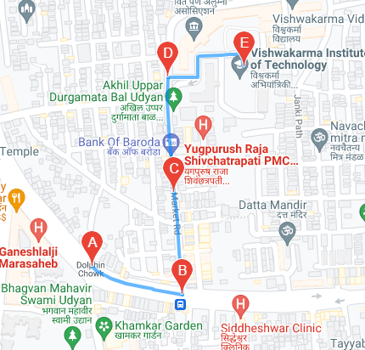

**Fig.6.** Map showing path from Dolphin chowk to V I T

The route is also verified using satellite view. The output of the system was examined and compared with the actual route, which is depicted on the map correctly indicates that the system is efficiently working as shown in Fig.7.

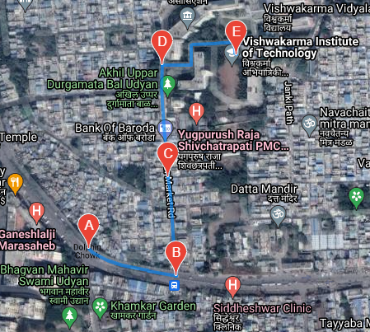

**Fig.7.** Map showing path from Dolphin chowk to V I T in satellite view.

# **Conclusion**

In this work, a solution for the navigation of blind people is proposed. The system is designed to guide blind person on his 100 frequently traveled path. A collection of frequently preferred pathways taken by individuals in their daily lives are considered for mapping. It is user friendly interface as user has to just press the key which is assigned with respect to source and destination and system will automatically displays the route between them. This method is both cost-effective and efficient. This gives the blind individual a portable, dependable, and long-lasting navigational choice. Also, the waypoint added in the path on the map gives more confidence to the user while using the system. With every new update, a new feature appears. In the future scope of this work through cognition, a preview of the path can be made available to the visually impaired person. This system can be extended to dynamically take updates from the existing navigation system and suggest alternative routes. A GPS can be added to track the user. Also, this will be useful to their relatives to track them. The limitation of this system is that it is limited to one specific area. This system makes blind people feel confident and independent.

# **Acknowledgements**

We express our sincere gratitude to the visually impaired participants in this study, orientation and mobility (O&M) experts and authorities at The Poona Blind Men’s Association, Pune. The authors thank the La Foundation Dassault Systèmes, India and Vishwakarma Institute of Technology Pune for providing support (IN-2019-056) to carry out this research work.

##### **References**

1. Manduchi, Roberto, and Sri Kurniawan. "Mobility-related accidents experienced by people with visual impairment." AER Journal: Research and Practice in Visual Impairment and Blindness 4, no. 2 (2011): 44-54.
2. Zeng, Limin. "A survey: outdoor mobility experiences by the visually impaired." In *Mensch und Computer 2015–Workshopband*, pp. 391-398. De Gruyter, 2015.
3. Ackland, Peter et al. “World blindness and visual impairment: despite many successes, the problem is growing.” Community eye health vol. 30,100 (2017): 71-73
4. Blindness and Visual impairments: Global Facts. (2012, February 1).[Online]. Available:http://www.vision2020.org
5. J. Faria, S. Lopes, H. Fernandes, P. Martins and J. Barroso, "Electronic white cane for blind people navigation assistance," *2010 World Automation Congress*, 2010, pp. 1-7.
6. R. Pyun, Y. Kim, P. Wespe, R. Gassert and S. Schneller, "Advanced Augmented White Cane with obstacle height and distance feedback," 2013 IEEE 13th International Conference on Rehabilitation Robotics (ICORR), 2013, pp. 1-6, doi: 10.1109/ICORR.2013.6650358.
7. K. Iwatsuka, K. Yamamoto and K. Kato, "Development of a guide dog system for the blind people with character recognition ability," Proceedings of the 17th International Conference on Pattern Recognition, 2004. ICPR 2004., 2004, pp. 453-456 Vol.1, doi: 10.1109/ICPR.2004.1334161.
8. Shrivastava, Prasun, Praveen Anand, Akash Singh, and V. Sagar."Medico stick: An ease to blind & deaf." In 2015 2nd International Conference on Electronics and Communication Systems (ICECS), pp. 1448-1452. IEEE, 2015.
9. Zeng, Limin, Denise Prescher, and Gerhard Weber. "Exploration and avoidance of surrounding obstacles for the visually impaired." In *Proceedings of the 14th international ACM SIGACCESS conference on Computers and accessibility*, pp. 111-118. 2012.
10. Wang, Z., Li, N., Li, B.: Fast and independent access to map directions for people who are blind. Interact. Comput. 24, 91–106 (2012)
11. Zeng, L., Miao, M., Weber, G.: Interactive audio-haptic map explorer on a tactile display. Interact. Comput. 27(4), 413–429 (2015)
12. Katz, B., Kammoon, S., Parseihian, G., Gutierrez, O., Brilhault, A., Auvray, M., Truilliet, P., Denis, M., Thorpe, S., Jouffrais, C.: NAVIG: augmented reality guidance system for the visually impaired. Virtual Reality 16(4), 253–269 (2012)
13. Yatani, K., Banovic, N., Truong, K.N.: SpaceSense: representing geographical information to visually impaired people using spatial tactile feedback. In: Proceedings of ACM CHI 2012, pp. 415–424 (2012)Md. Allama Ikbal, Faidur Rahman, Md. Ripon Ali, M. Hasnat Kabir, and Hidemitsu Furukawa "Smart walking stick for blind people: an application of 3D printer", Proc. SPIE 10167, Nanosensors, Biosensors, Info-Tech Sensors and 3D Systems 2017, 101670T (24 April 2017).
14. Patel, Samir, Amit Kumar, Pradeep Yadav, Jay Desai, and Dipali Patil. "Smartphone-based obstacle detection for visually impaired people." In 2017 International Conference on Innovations in Information, Embedded and Communication Systems (ICIIECS), pp. 1-3. IEEE, 2017.
15. Dhod, Rahul, Gurmohan Singh, Gagandeep Singh, and Manjit Kaur. "Low cost GPS and GSM based navigational aid for visually impaired people." Wireless Personal Communications92, no. 4 (2017): 1575-1589.
16. A. Noorithaya, M. K. Kumar and A. Sreedevi, "Voice assisted navigation system for the blind," International Conference on Circuits, Communication, Control and Computing, 2014, pp. 177-181, doi: 10.1109/CIMCA.2014.7057785.
17. Mohapatra B. N., Mohapatra R. K., and Panda P.. "Path guidance system for blind people" International Journal of Open Information Technologies, vol. 7, no. 5, 2019, pp. 29-32.
18. J. Borenstein and I. Ulrich, "The GuideCane-a computerized travel aid for the active guidance of blind pedestrians," Proceedings of International Conference on Robotics and Automation, 1997, pp. 1283-1288 vol.2, doi: 10.1109/ROBOT.1997.614314.
19. Farcy R., Bellik Y. (2002) Locomotion Assistance for the Blind. In: Keates S., Langdon P., Clarkson P.J., Robinson P. (eds) Universal Access and Assistive Technology. Springer, London. <https://doi.org/10.1007/978-1-4471-3719-1_27>
20. Zhan, F. Benjamin, and Charles E. Noon. "Shortest path algorithms: an evaluation using real road networks." Transportation science 32, no. 1 (1998): 65-73.
21. Loomis, Jack M., Reginald G. Golledge, and Roberta L. Klatzky. "GPS-based navigation systems for the visually impaired." Fundamentals of wearable computers and augmented reality 429 (2001): 46.
22. Gawari, Harsha, and Meeta Bakuli. "Voice and GPS based navigation system for visually impaired." *Int. J. Eng. Res. Appl* 4, no. 4 (2014): 2248-9622.
23. Nisha, K. K., H. R. Pruthvi, Shwetha N. Hadimani, G. Ram Mohana Reddy, T. S. Ashwin, and Shridhar Domanal. "An android gps-based navigation application for blind." In Proceedings of the 7th International Symposium on Visual Information Communication and Interaction, pp. 240-241. 2014.
24. Yelamarthi, Kumar, Daniel Haas, Daniel Nielsen, and Shawn Mothersell. "RFID and GPS integrated navigation system for the visually impaired." In 2010 53rd IEEE International Midwest Symposium on Circuits and Systems, pp. 1149-1152. IEEE, 2010.
25. Singh, Kalpana, M. Vashisht, D. Saxena Jyoti, and Harshita Tyagi. "Navigation System for Blind People using GPS & GSM Techniques." (2003): 1-15.
26. Lanning, Daniel R., Gregory K. Harrell, and Jin Wang. "Dijkstra's algorithm and Google maps." In Proceedings of the 2014 ACM Southeast Regional Conference, pp. 1-3. 2014.
27. Heuten, Wilko, Niels Henze, Susanne Boll, and Martin Pielot. "Tactile wayfinder: a non-visual support system for wayfinding." In Proceedings of the 5th Nordic conference on Human-computer interaction: building bridges, pp. 172-181. 2008.
28. Kreller, Isabella, and Bernd Ludwig. "User Preferences and the Shortest Path." arXiv preprint arXiv:2107.11150 (2021).